Whenever possible it is best to make calls to other APIs asynchronously. Doing something in the background and letting the user know it is done usually beats making the user wait for the slow thing to happen in real time. This might mean they see a blank page, or have no idea of progress for seconds, minutes, etc.
Sometimes things cannot be done asynchronously. This could be making a request to an authentication system, to find out if the username and password, token, etc. are valid. It could also be an API following a design pattern known as the Broker Pattern. This pattern is useful when you’re trying to build a new interface to disguise complexity in the background, maybe temporarily while you help two systems converge.
I have seen the proper pattern used at work after acquiring another company, we made a new “membership system” and that API would talk to the two different user/membership systems behind the scenes, converting those systems payloads into one unified interface for consumers. It was not the most performant, but it let clients move over to the new system while we worked on unifying the systems in the background. Eventually when we were able to completely merge the systems (getting both sources of data into the new membership system), we kept the response contracts exactly the same, making it no longer a broker (and therefore a bunch quicker!)
In an ideal world each service knows enough information to satisfy its clients requests, but often there are unfortunate requirements (like the one above) for data to be fetched, or actions to be confirmed, on the fly. All of these things take time, and many developers make a mistake in assuming that it will always be quick.
Frontend applications (desktop, web, iOS, Android, etc.) talk to services, and services talk to other services. This chain of calls can stack up, as service A calls service B, unaware that system is calling service C and D… So long as A, B, C and D are functioning normally, the frontend application can hope to get a response from service A within a “reasonable time”, but if B, C or D are having a bad time, it can cause a domino effect that takes out a large chunk of your architecture, and the ripple effects result in a slow experience for the end users.
Slow applications can cost you a lot of money. A Kissmetrics survey suggests that for every additional second a page takes to load, 7% fewer conversions will occur, so its important to keep as much of the user experience functioning as well as possible, for as long as possible, even when upstream dependencies are having a rough time.

Other People's Problems
You own service A, and are making calls to service B. What happens when service B has a bad day, and instead of responding within the usual ~350ms, it starts to take 10 seconds? Do you want to wait 10 seconds for that response?
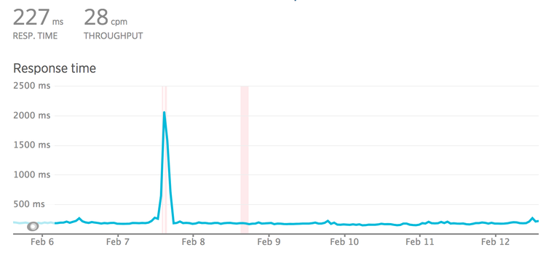
What about if service B is fine, but C is taking 20s and D is taking 25s? Are you happy to wait 45 seconds for the response from B?
What about two minutes?! 😱

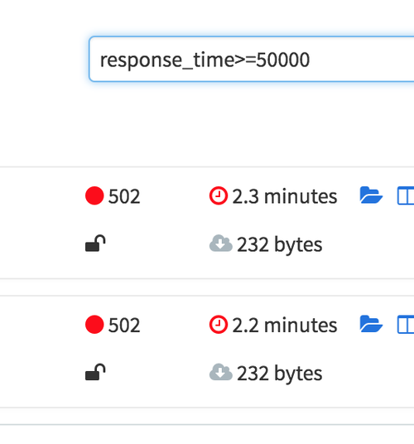

When a server is under load, it can do some pretty wild stuff, and not all servers know to give up. Even fewer client applications know when to give up waiting for the server, and those that do will take a while to do it.
For example, if service B is on Heroku, we can be confident the request is not going to last for more than 30 seconds. Heroku's router has a policy: applications get 30 seconds to send the first byte, and if that doesn't happen then the request gets dropped.
Quite often in monitoring systems like NewRelic or CA APM, you will see things like this:
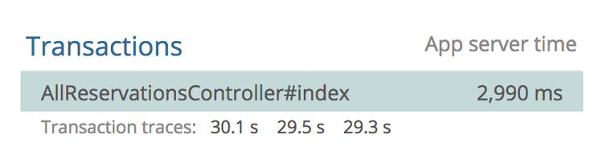
This controller has an average response time of 2.9s, but the slow ones are floating right around that 30s mark. The Heroku Chop saves the caller from being stuck there indefinitely, but this behavior is not widespread. Other web servers with different policies could hang for longer, or forever.
For this reason, never presume any service is going to respond as fast as it usually does. Even if that team’s developers are super confident. Even if it autoscales. Even if it's built in Scala. If you don't set timeouts, other people's problems become your problems.
So, how can we prevent slow requests from making our clients hang indefinitely?
A client can simply say “If it ain't done in 2 seconds, I’m done. I got other stuff to do.” This concept is known as a “timeout”.

Set Timeouts in the HTTP Client
HTTP clients usually do not set a timeout by default, but accept configuration to control various aspects of timeout settings.
For Ruby users, the HTTP client Faraday might look like this:
conn = Faraday.new('http://example.com');

conn.get do |req|
req.url '/search'
req.options.timeout = 5 # open/read timeout in seconds
req.options.open_timeout = 2 # connection open timeout in seconds
end
For PHP, Guzzle does this:
$client->request('GET', '/delay/5', ['timeout' => 5]);
There are two types of timeout that a lot of HTTP clients use:
- Open (Connection) Timeout
- Read Timeout
An open timeout asks: how long do you want to wait around to see if this server is actually accepting requests. That can mean many things but often means a server is too busy to take a request (there are no available workers processing the traffic). It also depends in part on expected network latency. If you are making an HTTP call to another service in the same data center, the latency is going to be a few milliseconds, but going to another continent takes time.

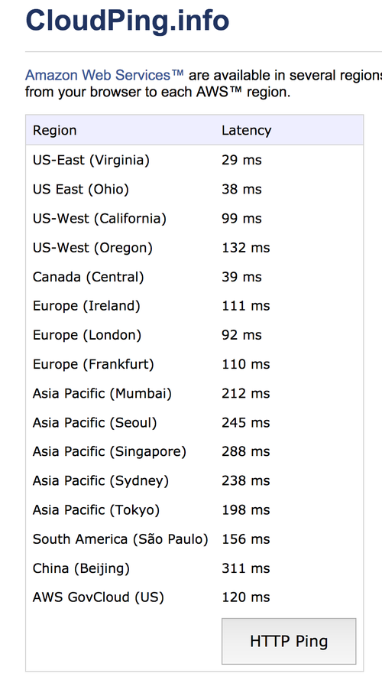

The read timeout is how long you want to spend reading data from the server once the connection is open. It's common for this to be set higher, as waiting for a server to generate an answer (run queries, fetch data, serialize it, etc.) should take longer than opening the connection.
When you see the term "timeout" on its own (not an open timeout or a read timeout) that usually means the total timeout. Faraday takes `timeout = 5` and `open_timeout = 2` to mean "I demand the server marks the connection as open within 2 seconds, then regardless of how long that took, it only has 5 seconds to finish responding."
For JavaScript users using `fetch()` you’re stuck wrapping fetch and making your own deadline option…
const oldfetch = fetch;
fetch = function(input, opts) {
return new Promise((resolve, reject) => {
setTimeout(reject, opts.deadline);
oldfetch(input, opts).then(resolve, reject);
});
}
Code snippet taken from a comment on whatwg/fetch. Same idea in that it runs the error case, but the connection is not actually being aborted. That could lead to some interesting issues… hopefully fetch() gets proper timeouts before too long.

